**Brevity**

Revise the following sentences to eliminate wordiness. (Suggested revisions appear following the sentences below.)

1. Regardless of the time of day, whenever anyone called for someone to help in doing some certain thing, Karen was always the very first person to volunteer her precious time and lend her much needed help for the cause at hand.

2. This spirit of cooperation is entirely essential and completely necessary for anyone to have in order to get along with other people and fellow citizens, and this is a particular quality that Christy possessed in ample supply and abundance.

3. Jonathan found his neighbour who happened to live next door to him to be quite possibly one of the most helpful and caring humans that he had ever encountered in his life.

4. Although they were basically several in number at the period of time when the specific research was conducted, the authors that were part of the research team generally felt that they could have quite possibly used several more researchers to fully and adequately complete the study.

5. It is highly unlikely and actually very unusual to find someone who has rarely, or quite possibly never, told a deliberate lie on purpose.

6. Mark was really late to his English class due to the fact that he had to finish his very lengthy math test.

7. According to most measures, the specific subjects that are considered the most important by college students are those subject areas of study that have been shown to be especially useful to them beyond the time following their graduation from colleges and universities.

8. Jake willingly provided a detailed and thorough explanation of the unique problem to his grandfather whose name is Jerry.

9. It is fully expected that the new revised schedule will be announced by the administration within the course of the next few days.

10. If you go to the store, you will see that the store is closed on Sunday due to the fact that the storeowner likes to go to church.

11. Terrible and unspeakable tragedy might be caused when people willingly and without hesitation disobey rules that have been established by the governing authorities who are in charge for the safety of all people under their jurisdiction.

12. During the period of time when I lived in the great state of Ohio, it was my clear intention to go to college in Texas.

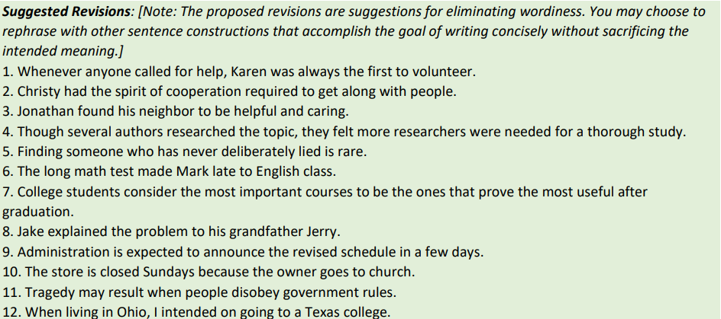

**Clarity**

Study each of the following ambiguous sentences carefully and underline the word or words that make(s) the sentence ambiguous. Then, in the blank provided, give two possible meanings in complete sentences for each.

1. Mary thinks the present is nice.

2. She is standing near the bank.

3. An old friend of mine teaches at that school.

4. Children may feed animals.

5. It must be a new record.

6. The lamb is too hot to eat.

7. The man looked backward.

8. The German teachers visited the British Museum yesterday.

9. Ralph took my picture.

10. The student must know the answer.

11. She cannot bear children.

12. We will give you a ring tonight.

Study each of the following ambiguous sentences carefully. Then, in the blank provided, give two possible meanings for each.

1. They fed her dog biscuits.

* *Biscuits were fed to her pet dog by them.*
* *She was fed biscuits meant for dogs.*

1. Enough rest and exercise will help you recover.
2. She can give more possible conclusions.
3. I like ice-cream and cake.
4. At the rehearsal she sang, danced, and tumbled very expertly.
5. I repaired the car and returned the following day.
6. What John disliked was being ignored by everyone.
7. Mary likes me more than Susan.
8. Tall boys and girls are needed to participate in the activities.
9. Henry washed the car in the garage.
10. We gave the library books.
11. They considered those problems.

Explain the cause of ambiguity in each of the following sentences.

1.Mother has baked potatoes for dinner.

* *Mother eats baked potatoes for dinner.*
* *Mother makes baked potatoes for dinner.*

2. My uncle likes walking and bathing dogs.

3. Jane paints pictures and sings well.

4. They are discouraging students.

5. We bought her pearl necklaces last month.